Multi-session Art and Social Justice Workshop at the New Museum

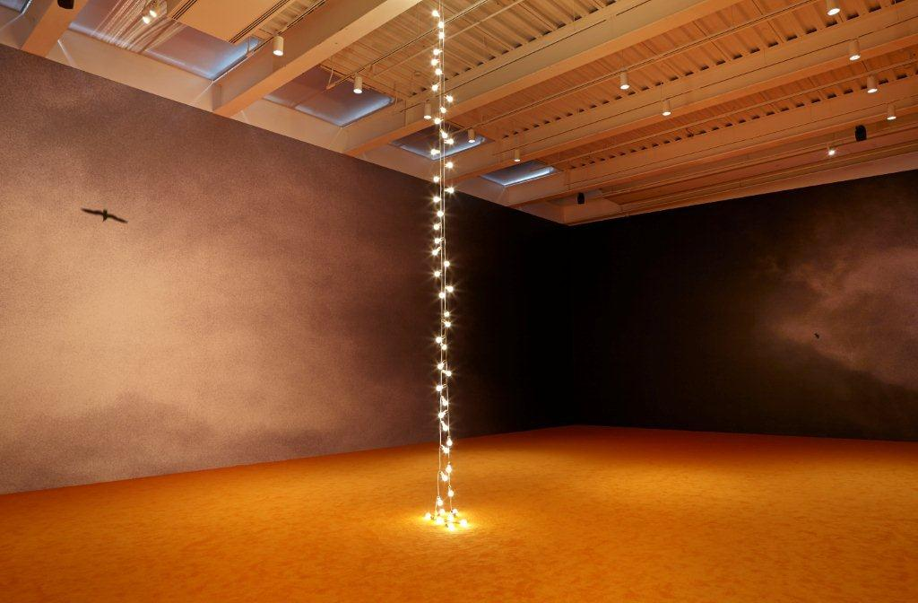
“NYC 1993: Experimental Jet Set, Trash and No Star,” 2013. Exhibition view: New Museum. Photo: Benoit Pailley
Join New Museum and NYCORE (New York Collective of Radical Educators) educators in a FREE interactive workshop series that introduces teachers to using contemporary art in the classroom. Participants will focus intensively on the art and artists featured in the New Museum’s current exhibition “NYC 1993: Jet Set, Trash and No Star,” exploring issues of social justice in contemporary art. Participants will also engage in group discussion and have the opportunity to reflect on how to take workshop activities and strategies back into the classroom. This multipart workshop is recommended for teachers interested in strategies and content appropriate for high school–age audiences.

Founded in 1977, the New Museum is located on Bowery at Prince Street and is a leading destination for new art and new ideas. It is Manhattan's only dedicated contemporary art museum.

Schedule:
Thursday April 11, 5:00–6:30 PM
Thursday April 18, 5:00–6:30 PM
Thursday April 25, 5:00–6:30 PM

Facilitators:
New Museum Associate Educator Audrey Hope and Associate Director of Education Jen Song, and NYCORE educators Stephane Barile and Lisbeth Woodington

Location:
New Museum, 235 Bowery, New York, NY 10002

Registration:
To register, please email gclass@newmuseum.org or call 212.219.1222 x231 with questions. Attendance is limited. Participants are required to attend all three sessions.

The Global Classroom is made possible, in part, by the Bloomingdale’s Fund of the Macy’s Foundation, Con Edison, the May and Samuel Rudin Family Foundation, and the New York City Department of Cultural Affairs. Additional support provided by the Laurie M. Tisch Illumination Fund.
Generous endowment support is provided by the Keith Haring Foundation School and Youth Programs Fund, the Rockefeller Brothers Fund, the Skadden, Arps Education Programs Fund, and the William Randolph Hearst Endowed Fund for Education Programs at the New Museum.
Additional endowment support provided by the JPMorgan Chase Professional Development Workshop Program for Teachers.
Support for the exhibition is provided by the Horace W. Goldsmith Foundation.
Additional funding is provided by Martin and Rebecca
Eisenberg, the Fundación Almine y Bernard Ruiz-Picasso para el Arte, and the Robert Mapplethorpe Photography Fund.
The accompanying exhibition publication is made possible by the J. McSweeney and G. Mills Publications Fund at the New Museum.

